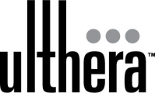

Ultherapy™

Post-Treatment Instructions

Typically, you may return to your normal activities after Ultherapy™. You should, however, follow the medical advice of your physician regarding the care of your skin.

- Wash skin with cool water and a gentle cleanser.

- If the skin is slightly pink or red in areas following the treatment, avoid hot water when washing or showering until the ‘blush’ has subsided (usually within an hour).

- Avoid exfoliation for at least one week or until all sensitivity in the treatment area has subsided.

- Makeup (preferably mineral-based) may be applied immediately post treatment.

- Soothing, non-irritating creams or moisturizers may be used.

6. Use a sun block with an SPF of 30 or greater if going out into the sun to help prevent
future sun damage.

Your practitioner will describe the nature and timing of possible changes you may notice over time from Ultherapy. If you have any further questions or concerns, contact your physician’s office.

4005EN022509

