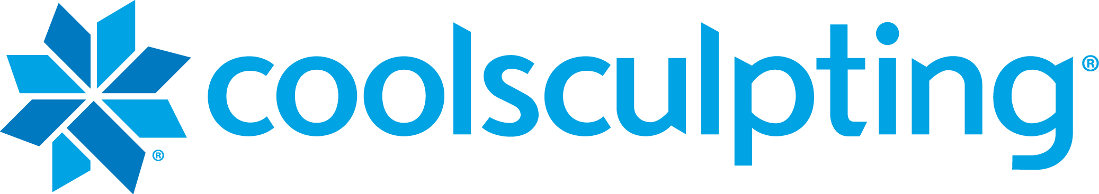
Patient Take-home GUidelines

What to expect after the CoolSculpting procedure:
» Typically, there is minimal discomfort and recovery time after the CoolSculpting procedure. Most patients are able to return to their daily routine immediately after the procedure
» The treated area may be red for up to a few hours after the applicator is removed.
» Many patients have minimal discomfort following the procedure, however you may experience one or more of the following sensations: deep itching, tingling, numbness, tenderness to the touch, pain in the treated area, strong cramping, nausea, bloating, diarrhea, muscle spasms, aching and/or soreness. Consult your doctor if these conditions persist beyond two weeks or worsen over time.
» Following the procedure, a gradual reduction in the thickness of the fat layer will take place. You may start to see changes as early as three weeks after the CoolSculpting procedure and you will experience the most dramatic results after one to three months. Your body will continue naturally to process the injured fat cells from your body for approximately four months after your procedure.
» In rare cases, patients have reported darker skin color, hardness, discrete nodules, freeze burn, enlargement of the treated area, hernia or worsening of existing hernia following the CoolSculpting procedure. Surgical intervention may be required to correct the enlargement or hernia.

Next steps:
» Weight gain will prevent you from appreciating your full results. Maintaining a healthy diet and exercise routine
after your procedure can help prevent this.
» Schedule a follow-up medical assessment to review your clinical results and discuss the option of additional
treatments to achieve desired fat reduction.

Please call us at 281-362-0014 if your symptoms appear to worsen or last longer than two weeks.

